Cephalosporin Clinical Decision Support System
Hackathon ISoP - Medication Errors Prevention Project

Team 5 members:
- Paulina Becerra Vivancoª (paulina.becerravo@udlap.mx) - Team leader
- Nuria Arroyo Bustamante^{b}
- José Ángel Palomares Velázquez^{b}
- Heriberto Espino Montelongo^{b}
- Juan Alonso Martínez Thomas^{c}
- Roberto Rosas Romero^{d} - Team advisor
- Lucila Isabel Castro Pastrana^{c} (lucila.castro@udlap.mx) - Team advisor

Disciplines of the team members:
ªBiomedical Engineering
^{b}Data Science / Actuarial Sciences
^{c}Chemical, pharmaceutical and biological Science
^{d}Computational Science

Topics
- Prevention of high alert Medication Errors / Special populations: elderly, pregnant and children
- Safe use of medication in hospitals / Healthcare professionals support

Background
According to Global Antimicrobial Use (AMU) Data, cephalosporins constituted approximately 7% of global antibiotic consumption in 2023. This usage figure increases to 8% within low- and middle-income countries, which translates to 1.2 daily doses of cephalosporins prescribed per 1,000 inhabitants. Regarding the specific classes of cephalosporins usually consumed, statistics indicate a prescribing preference for third-generation agents, such as cefotaxime or cefixime (1).
In this context, as reported by Klein et al. (2024), the consumption of cephalosporins in low- and middle-income countries doubled between 2016 and 2023 (2). Furthermore, the inclusion of several cephalosporins in the 24th WHO Model List of Essential Medicines, published in 2025, supports the premise that their utilization will continue in the near future (3).
In this sense, it has been widely reported that β-lactam antibiotics can cause seizures due to the similarity of the beta-lactamic ring with the neurotransmitter GABA, reason why the antibiotics can easily bind the GABA A receptor and play an antagonic role in the GABAergic transmission (4). Particularly referring to cephalosporins, the neurotoxic effect observed is dose-dependant, and according to existing litterature reports, cefazoline is the most epileptogenic drug in this group (5).
Regarding to the risk factors associated with convulsions, several studies have observed a correlation with renal impairment, previous central nervous systems diseases, older age, multiple concomitant therapies and concomitant medical conditions (6). Moreover, Haddad et al. (2022) developed a multivariable neurotoxicity assessment tool to predict the risk of developing neurotoxicity after β-lactamic administration, which considered patient weight, age, estimated creatinine clearance and Charlson comorbidity score (7).

Problem identification
A global safety alert of risk of seizures with cephalosporins was issued by the FDA in 2012, aiming to influence prescription practices, promote rational antibiotic use and guide risk communication (8). Additionally, in the first semester of 2023, alerts regarding the potential risk of seizure onset were published by the health agencies of several countries, including Mexico, Canada, New Zealand, and Chile (9–13).
However, the diffusion of national and international sanitary alerts without adequate evidential support may lead physicians to make inappropriate medical decisions. The lack of publicly available information, including data on incidence rates, risk factors and the specific drugs involved in adverse reactions, could result in either an overestimation or underestimation of the actual risk.
In this regard, the sanitary alert (Illustration 1) issued by the Federal Commission for Protection against Health Risks (COFEPRIS), the Mexican health regulatory agency, is an accurate example of an alert based on international evidence that fails to provide relevant information for prescribing healthcare professionals, such as a clear context and locally available data (9,10). Similarly, other low- and middle-income countries also face challenges related misinformation, as pharmacovigilance agencies often do not provide healthcare professionals with the regional data, thereby increasing the risk of inadequate prescribing decisions.
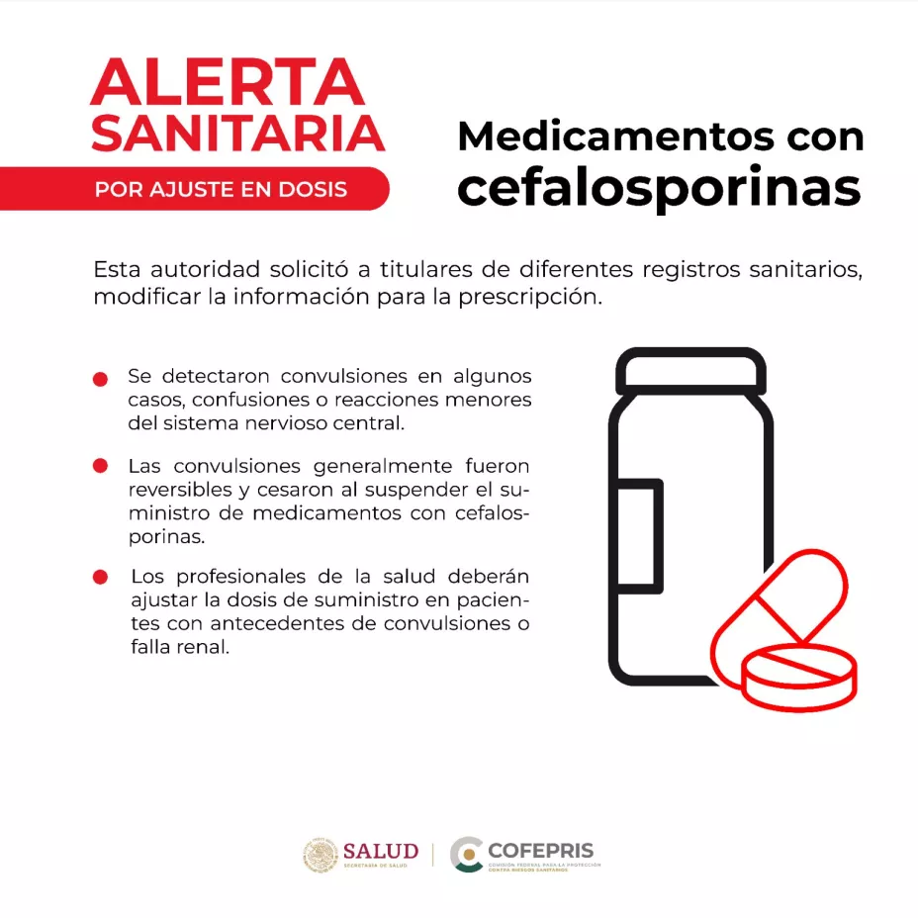
Illustration 1: Sanitary alert issued by COFEPRIS concerning risk associated to cephalosporins [10]

Moreover, in many low- and middle-income countries, such non-specific alerts create uncertainty among prescribing physicians. The availability of specific cephalosporins differs by region, and the alert’s reference to the entire drug class, without distinguishing risk by molecule, dose, age, or patient’s renal function, limits its practical value. Lacking local evidence, physicians may question whether the warning reflects a real regional concern or data from other contexts, potentially leading to the unnecessary avoidance of safe and effective agents and the use of less appropriate or more costly alternatives.

Stakeholders involved
- Prescribers, physicians and health care practitioners
- Regulatory agencies
- Patients and consumers

Proposal
We propose the development and implementation of a clinical decision support system (CDSS) designed to provide patient-specific risk stratification for cephalosporin-induced adverse effects. This system addresses the ambiguity of general health alerts by integrating two distinct analytical approaches—a traditional pharmacoepidemiologic model and a machine learning model—into a single, interactive application. For this purpose, the following accessible databases were used as main source of information:
- Government of Canada. (2023, November 8). Age (in single years), average age and median age and gender: Canada, provinces and territories, divisions of recensus and census subdivisions [Data set]. Open Government Portal. https://open.canada.ca/data/dataset/6acff169-8026-47ef-abec-3ec34e0b02fa (Open Government Canada)
- Government of Canada. (2025, May 29). Canada Vigilance Adverse Reaction Online Database – Data structure. Health Canada. https://www.canada.ca/en/health-canada/services/drugs-health-products/medeffect-canada/adverse-reac… (Canada)
- Government of Canada. (2023). Age (in years), average age and median age and gender: Canada, provinces and territories, divisions of recensus and census subdivisions [Data set]. Publications G C. https://publications.gc.ca/collections/collection_2024/statcan/91-215-x2023002-eng.pdf
- Government of Canada. (n.a.). Archive — Age (in years), average age and median age and gender: Canada, provinces and territories, divisions of recensus and census subdivisions [Archived data set]. https://publications.gc.ca/site/archivee-archived.html?url=https%3A%2F%2Fpublications.gc.ca%2Fcolle…
(Accessed 2025 Nov 12)
- Government of Canada. (2020, June 29). Canadian Antimicrobial Resistance Surveillance System (CARSS) – Update 2020: Report. Public Health Agency of Canada. https://www.cahss.ca/CAHSS/Assets/Documents/CARSS-2020-Canadian-Antimicrobial-Resistance-Surveillan… (Canada)
- Government of Canada. (n.d.). Canadian Antimicrobial Resistance Surveillance System (CARSS) [Web page]. https://health-infobase.canada.ca/carss/
(Accessed 2025 Nov 12)
- Government of Canada. (2011). Canadian Integrated Program for Antimicrobial Resistance Surveillance (CIPARS) Human Antimicrobial Use Short Report, 2000–2009. Public Health Agency of Canada. https://www.phac-aspc.gc.ca/cipars-picra/2009/pdf/2009pr-eng.pdf (Public Health Agency of Canada)

Based on the analysis of these databases, the development stack leverages Python for its core logic, utilizing robust data manipulation libraries such as Polars and Pandas for efficient data preprocessing, cleaning, and feature engineering, including the imputation of missing values as seen in the 03_02 Una Mejor Imputacion.ipynb notebook. The dual-approach methodology consists of:

- Pharmacoepidemiological (PE) Hybrid Model: As outlined in the 03 vean este.ipynb analysis, this model calculates a smoothed, age-adjusted probability of an adverse event (AE) occurring (prob_ea). This hybrid approach provides an interpretable, statistically grounded metric that clinicians can use to understand baseline risk.
- Machine Learning (ML) Predictive Model: Leveraging the CatBoostClassifier library, as detailed in 03_03 Catboost.ipynb, we have trained a sophisticated gradient-boosting model. This model excels at identifying complex, non-linear relationships and interactions between patient features (e.g., concomitant medications) that simpler models might miss. Its performance is rigorously evaluated using metrics like ROC-AUC and average precision score, and its "Feature Importance" analysis helps identify key risk drivers.

Additionally, the previously described model was introduced to an interface designed as a streamlined and intuitive environment that supports clinicians in organizing patient information and managing treatment-related data efficiently. The system centres around a clear and structured layout, beginning with a dedicated patient information section where users enter essential demographic and physiological details. Each field is carefully arranged to reflect the flow of a typical clinical assessment, with inputs for age, sex, height, weight, and other relevant descriptors positioned logically to reduce cognitive burden during data entry. The design supports both keyboard and mouse interaction, and the use of clean typography and spacing ensures that fields are easy to identify and navigate.
One of the defining features of the interface is its medication input module. Instead of relying on static dropdown menus or long checklists, the system incorporates an intelligent autocomplete text box that recognizes medication names from a curated and standardized list. As the user begins typing, the interface dynamically suggests matching drug names, significantly reducing errors caused by misspellings or inconsistencies in nomenclature. This approach also accommodates scenarios in which patients take multiple medications: users simply add them one by one, with each entry automatically converted into the standardized format used internally by the system. This improves data quality and ensures that later analyses are based on harmonized medication descriptions regardless of how the user initially typed them.
Another important component of the interface is its integrated patient file management system. The backend relies on a robust SQLite database that securely stores patient information, medication records, timestamps, and any additional data fields that evolve during the consultation process. When the user completes an assessment, the system automatically creates or updates the patient’s file, ensuring that all information is preserved for future use. Clinicians can easily load existing patient records through a search and selection tool that presents names and identifiers in a clean, accessible format. Once a record is opened, all fields populate instantly, allowing the user to continue previous assessments, make corrections, or add new information. The interface also provides options for deleting outdated or unnecessary records, giving clinicians full control over their data while maintaining a clear and organized database.
The user interface (Illustration 2) prioritizes accessibility and visual clarity. A scrollable main window ensures that all components remain orderly and visible, even as the system expands to include additional sections or future functionalities. Buttons for key actions, such as saving information, clearing the form, updating files, or browsing patient history, are placed in prominent, intuitive positions that correspond to natural user workflows. Visual groupings, margins, and spacing guide the eye across the interface, reducing the need for users to search for controls or scan cluttered layouts. This thoughtful design results in an interface that feels open, predictable, and manageable, even for users with minimal technical experience. Importantly, the program was intentionally designed to run smoothly on virtually any modern physician’s device, without the need for specialized hardware or high-performance computing resources. Its lightweight architecture, reliance on widely supported libraries, and modest processing requirements ensure that practitioners can benefit from its functionality whether they are using a basic clinic workstation, a personal laptop, or a standard office computer, making the tool both practical and broadly accessible in real-world healthcare settings.

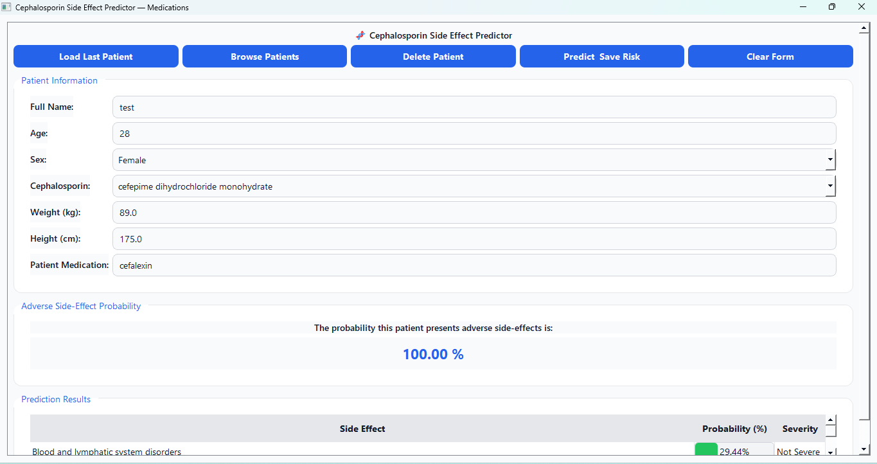
Illustration 2: Main screen of the CDSS

Beyond usability, the interface delivers several important practical benefits. It centralizes patient information, reducing reliance on multiple tools or paper records and minimizing the risk of data fragmentation. Because entries remain consistent and standardized, clinicians can trust that patient histories remain accurate and complete over time. The ability to update existing records rather than recreate them enhances efficiency and supports longitudinal monitoring, allowing clinicians to compare past and present data during follow-up consultations. The interface also encourages better documentation habits by making it easy to save, review, and modify patient files in a structured manner.
Despite its strengths, the system also provides opportunities for continuous improvement. Future extensions could include integration with hospital information systems or electronic health records to automate data import and export, thereby reducing manual entry. Additional modules—such as laboratory results, imaging reports, or clinical notes—could enrich patient profiles and support more comprehensive clinical decision-making. User personalization features, including customizable layouts or quick-access shortcuts, could improve workflow efficiency for different medical specialties.
Finally, expanding the interface to mobile or web-based platforms would increase accessibility and enable the system to support clinicians across a wider range of care environments. This tool allows a prescribing physician to input the patient data (such as age, weight, height, gender, etc.). The system then evaluates this data in real-time and returns both metrics: the statistical probability from the PE model and the predictive risk score from the ML model. This dual output provides clinicians with both an interpretable probability and a high-accuracy predictive assessment, enabling a truly evidence-based decision at the point of care.

The whole data analysis, the development of the dual approach methodology and the code for the user-friendly interface are available on: https://github.com/heritaco/Cephalosporines

Discussion
The development of this clinical decision support system (CDSS) emerges as a direct response to the uncertainty generated by non-specific health alerts such as the risk of seizures associated with cephalosporins. While regulatory agencies, such as COFEPRIS in Mexico, issue warnings based on international evidence, these lack the most essential evidential support for decision-making at the point of care, as they warn of a risk associated to a drug class, without providing local data or stratifying the risk by specific patient or drug involved. In this sense, our interface is designed precisely to bridge this gap, translating a general alert into a personalized and actionable risk assessment.
The reliance on international alerts in low- and middle-income countries (LMICs), as a direct consequence of inefficient local pharmacovigilance practices, has a significant impact on the clinical management of patients. In this sense, the developed tool could be helpful in the aspects listed before.
First, the current problem is that a physician, alarmed by a general alert may choose to "unnecessarily avoid safe and effective agents," as was noted in the introduction. This avoidance behavior leads to a false sense of security and a loss of valuable data, as the drug is not used in the patient who would have benefited, and its true safety profile in the local population is never observed. Our tool, by quantifying the risk and showing it to be low in many patients, gives the physician the confidence to prescribe the appropriate agent, thus combating the risk of misinformation.
On the opposite scenario, sensitization from the alert can cause over-attribution, and any neurological event in a patient receiving cephalosporins, even low-risk ones, could be attributed and reported as an Adverse Drug Reaction (ADR). This situation could saturate the PV system with weak or false signals. In this sense, our interface acts as a quality filter: If the tool predicts a high risk for the "Nervous system disorders" SOC and the patient presents an event, the resulting report becomes a high-quality signal worthy of investigation. Conversely, an event in a patient with a low predicted risk would prompt the clinician to investigate other underlying causes.
Perhaps, the most critical impact of non-specific alerts is the promotion of inappropriate therapeutic substitution, a known driver of antimicrobial resistance (AMR). In this context, our tool functions as a vital mechanism for Antimicrobial Stewardship by directly addressing the risks identified in the introduction, where uncertainty often leads to the use of less appropriate or more costly alternatives. The greatest danger here is a class avoidance behavior, where a physician, fearing the seizure risk of all cephalosporins, might precipitously jump to a last-resort antibiotic. To mitigate this, the interface facilitates alignment with the WHO AWaRe classification, allowing physicians to confidently use cephalosporins from the "Access" or "Watch" lists, rather than unnecessarily escalating to "Reserve" antibiotics.
Specifically, this carbapenem-sparing effect prevents the increased use of agents like meropenem for infections that a standard cephalosporin could have resolved, thereby slowing the selection of carbapenem-producing Enterobacteriaceae, which represents a devastating global public health threat. Moreover, the tool reinforces evidence-based guidelines by reconciling the gap between clinical evidence, which supports cephalosporins as essential medicines, and the safety fears generated by regulatory alerts. By demonstrating that the risk is patient- and drug-specific rather than universal, it promotes rational prescribing that remains aligned with established guidelines.
Nevertheless, despite its potential, the implementation of this model in the Mexican context and other low- and middle-income countries faces the very same barriers it criticizes in current health alerts. A primary limitation concerns the lack of regional pharmacovigilance data, which directly impacts the validity of the training set. If the model relies heavily on international databases like the ones used in the development of our model or VigiBase, its predictive accuracy in the Mexican population remains questionable; therefore, to truly overcome the problem of alerts based on international evidence, the tool requires prospective validation and recalibration using local data.
Furthermore, while the current model is parsimonious to facilitate ease of use, it omits critical variables identified in the literature, such as renal impairment, prior CNS diseases, and concomitant therapies. Although this simplicity makes the model superior to a general alert, it renders it inferior to more complex tools, particularly regarding the absence of renal function, which is a known predictor of dose-dependent neurotoxicity. Finally, the utility of the tool is currently limited by a lack of clear decision algorithms. Merely presenting a physician with a "High General Risk" or an "Elevated Risk in Renal SOC" is informative but insufficient to guide clinical action. To avoid analysis paralysis and ensure the tool is transformative rather than just informative, it must be integrated with clear protocols indicating when to select an alternative, adjust the dose, or simply intensify monitoring.

Conclusions
This project successfully demonstrates the development and integration of a dual-approach clinical decision support system to translate non-specific health alerts into actionable, patient-specific risk assessments. By bridging the gap between general regulatory warnings and individual patient care, our tool directly confronts the problem of clinical uncertainty in low- and middle-income countries.
The key innovation of this system is its synthesis of two distinct methodologies: an interpretable, pharmacoepidemiologic hybrid model and a high-performance CatBoost machine learning model. This combination provides healthcare professionals with a multifaceted view of risk, offering both a clear statistical probability and a nuanced predictive score derived from complex data patterns.
Additionally, the benefit/cost ratio of this proposal is projected to be highly favourable, as the primary costs are front-loaded, consisting of the initial development (data sourcing, model training, and interface design) and integration, while the marginal cost per use for the clinician is negligible, as it requires no new laboratory tests, genomic sequencing, or expensive diagnostics. Moreover, the tool directly mitigates the costs associated with preventable ADRs, including costs of corrective treatment, prolonged hospitalization, and management of long-term sequelae. he innovation of this proposal lies not in the concept of risk prediction itself, but in its pragmatic design and actionable output.
While complex models that incorporate renal function and comorbidities exist, the key innovation of our tool is its practical simplicity, making it highly accessible and easy to use in clinical settings. By relying only on universally available data points (age, gender, height, and prescribed drug), it is designed for maximum accessibility in data-poor environments where creatinine clearance or Charlson scores may not be immediately available.
Overall, the resulting interactive application empowers clinicians to move from generalized, class-wide warnings about cephalosporins to personalized, evidence-based risk stratification. This work serves as a scalable prototype that can be adapted for other high-alert medications or populations, representing a tangible step toward safer and more rational medication use in resource-constrained settings.

Highlights of our project
General Applicability
- Combats misinformation: Quantifies risk, giving the clinician confidence to prescribe the appropriate cephalosporin.
- Quality filter: Generates high-quality reports for the pharmacovigilance system.
- Antimicrobial Stewardship: Avoids inappropriate therapeutic substitution and the use of last-resort antibiotics.
Applicability in LICs and MICs
- Highly affordable and scalable in LICs and MICs.
- Based on demographic data already reported in Pharmacovigilance databases.
Affordability and Relation Benefit/Cost
- Low implementation cost (primarily front-loaded costs).
- Prevention of costly adverse reactions.
- Mitigation of systemic antimicrobial resistance.
Innovation
- Pragmatic design and actionable output.
- Can take advantage of already existing data.
- Provides actionable, clinically specific risk predictions stratified by MedDRA SOC.

References
1. World Health Organization. Global AMU data [Internet]. 2023 [cited 2025 Nov 9]. Available from: https://worldhealthorg.shinyapps.io/glass-dashboard/_w_80d1a76db0ca42a1aa9d0d8068351ffc/#!/amu
2. Klein EY, Impalli I, Poleon S, Denoel P, Cipriano M, Van Boeckel TP, et al. Global trends in antibiotic consumption during 2016–2023 and future projections through 2030. Proceedings of the National Academy of Sciences. 2024 Dec 3;121(49):e2411919121.
3. World Health Organization. WHO Model List of Essential Medicines 24th list [Internet]. [cited 2025 Nov 10]. Available from: https://www.who.int/publications/i/item/B09474
4. Zou D, Zhang R, Yu L, Hu T, Wu B. Seizures associated with antibiotics: a real-world disproportionality analysis of FAERS database. Expert Opinion on Drug Safety. 2023 Nov 2;22(11):1143–8.
5. Sutter R, Rüegg S, Tschudin-Sutter S. Seizures as adverse events of antibiotic drugs. Neurology. 2015 Oct 13;85(15):1332–41.
6. Lacroix C, Kheloufi F, Montastruc F, Bennis Y, Pizzoglio V, Micallef J. Serious central nervous system side effects of cephalosporins: A national analysis of serious reports registered in the French Pharmacovigilance Database. Journal of the Neurological Sciences. 2019 Mar 15;398:196–201.
7. Haddad NA, Schreier DJ, Fugate JE, Gajic O, Hocker SE, Ice CJ, et al. Incidence and Predictive Factors Associated with Beta-Lactam Neurotoxicity in the Critically Ill: A Retrospective Cohort Study. Neurocrit Care. 2022 Aug 1;37(1):73–80.
8. Research C for DE and. FDA Drug Safety Communication: Cefepime and risk of seizure in patients not receiving dosage adjustments for kidney impairment. FDA [Internet]. 2019 Jun 26 [cited 2025 Nov 11]; Available from: https://www.fda.gov/drugs/drug-safety-and-availability/fda-drug-safety-communication-cefepime-and-risk-seizure-patients-not-receiving-dosage-adjustments
9. Svarch AE, Rosales MJL, Arceo DES, Quintana RR, Badillo MGC. Risk of Seizures Associated with the Use of Antibiotics from the Cephalosporin Group. Revista Mexicana de Política Exterior. 2024 Sep 26;(129):87–98.
10. Comisión Federal para la Protección Contra Riesgos Sanitarios. Gobierno de México. 2023 [cited 2025 Nov 10]. Cofepris alerta sobre prescripción de medicamentos con cefalosporinas. Available from: http://www.gob.mx/cofepris/articulos/cofepris-alerta-sobre-prescripcion-de-medicamentos-con-cefalosporinas?idiom=es
11. Health Canada. Summary Safety Review - Cephalosporins - Assessing the Potential Risk of Seizures [Internet]. 2023 [cited 2025 Nov 10]. Available from: https://dhpp.hpfb-dgpsa.ca/review-documents/resource/SSR00291
12. MEDSAFE New Zealand Medicines and Medical Devices Safety Authority. Risk of neurotoxicity with cephalosporins. Prescriber Update. 2023 Mar;44(1):2–4.
13. Instituto de Salud Pública, Ministerio de Salud. ISP REFUERZA ADVERTENCIA SOBRE EL RIESGO DE CONVULSIONES Y OTRAS REACCIONES DEL SISTEMA NERVIOSO CENTRAL, CON EL USO DE ANTIBIÓTICOS DE LA FAMILIA DE LAS CEFALOSPORINAS. 2024 May 27; Available from: https://www.ispch.gob.cl/alerta/isp-refuerza-advertencia-sobre-el-riesgo-de-convulsiones-y-otras-reacciones-del-sistema-nervioso-central-con-el-uso-de-antibioticos-de-la-familia-de-las-cefalosporinas/

